# Name: Abdurrahman Qureshi

# Roll No:210451

## Practical no:5

## Aim: Execute DML commands in SQL

Q1) CREATE A TABLE EMPLOYEE WITH THE FOLLOWING SCHEMA:

EMP(EMP_NO,E_NAME,DEPT_NO,DEPT_NAME,JOB_ID,SALARY,HIREDATE)

Output:

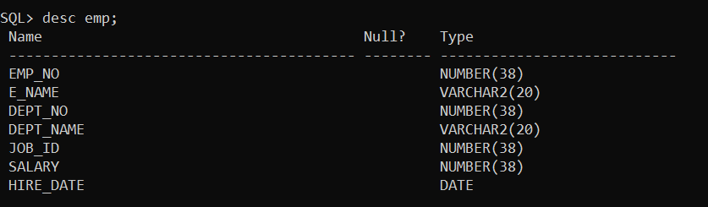

Q2) INSERT MULTIPLE ROWSIN EMP TABLE USING SINGLE INSERT COMMAND OF SQL:

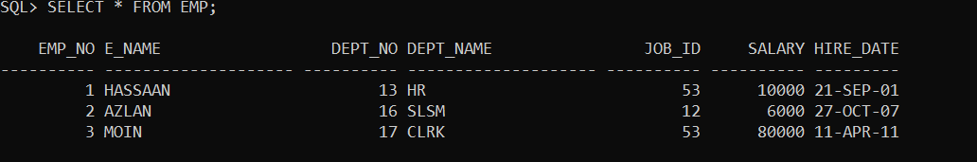Output: -

Q3) EXECUTE THE FOLLOWING QUERIES, DEBUG THE ERROR AND WRITE THE OUTPUT:

A. INSERT INTO VALUES (1,’SHREYAS’,100, SALES,111,40000,2014-09-28);

Output: -

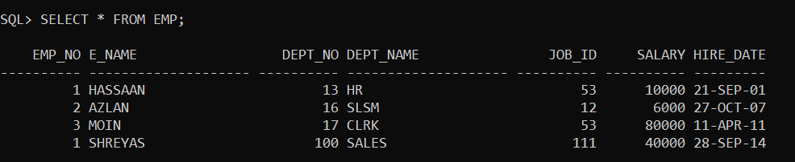

B. DELETE EMP WHERE E_NAME=’SHREYAS’;

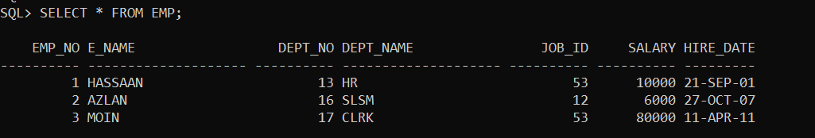Output: -

C.UPDATE SET SALARY=50000 WHERE DEPT_NO=PRODUCTION:

Output: -

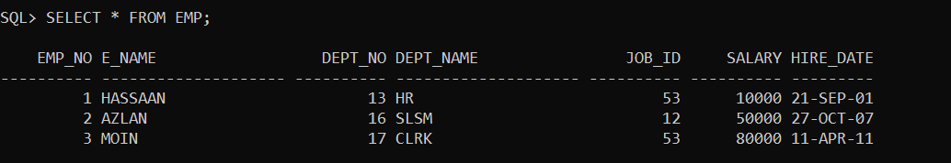

D.SELECT ALL FROM WHERE SALARY >=25000 AND <=60000:

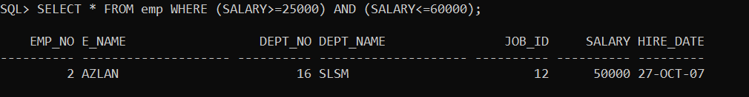Output: -

X|V. EXERCISE:

1.CREATE A TABLE EMPLOYEE WITH THE FOLLOWING SCHEMA:

EMP (EMP_NO, E_NAME, DEPT_NO, DEPT_NAME, JOB_ID, SALARY, HIREDATE);

WRITE SQL WUERIES FOR FOLLOWING QUESTION:

A. INSERT ATLEAST FIVE ROWS IN THE TABLE:

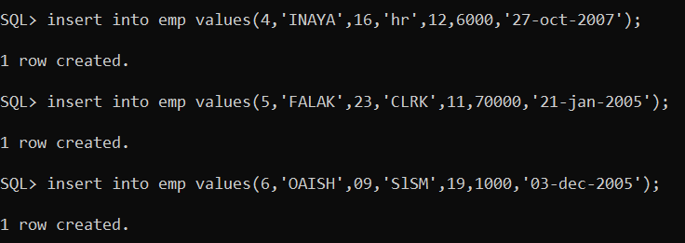

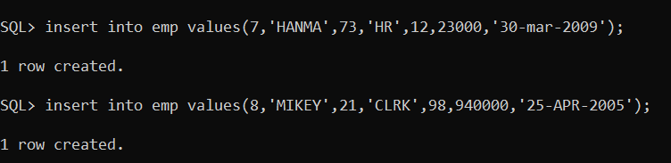

B. DISPLAY ALL THE INFORMATION OF EMP TABLE;

Output: -

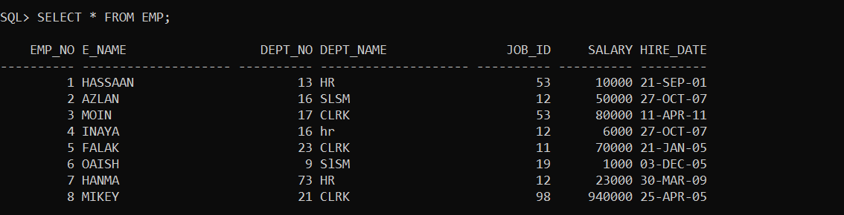

C.DISPLAY THE INFORMATION OF EMPLOYEES WORKIN IN DEPARTMENT PRODUCTION AND SALARY ABOVE 40000:

Output: -

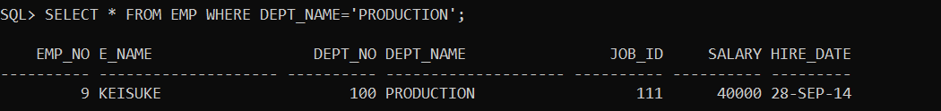

C.DISPLAY THE INFORMATION OF EMPLOYEES WORKIN IN DEPARTMENT PRODUCTION AND SALARY ABOVE 40000:

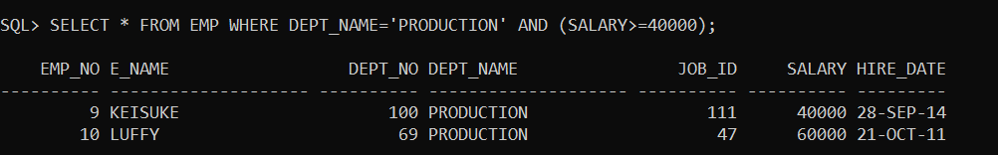Output: -

D.UPDATE THE SALARY OF EMPLOYEE TO 30000 WORKING IN DEPARTMENT SALES:

Output: -

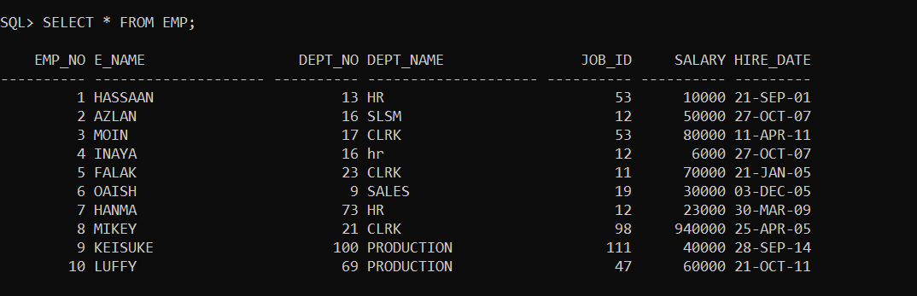

E. DELETE THE EMPLOYEE WORKING IN SALES DEPARTMENT HAVING SALARY BELOW 10000:

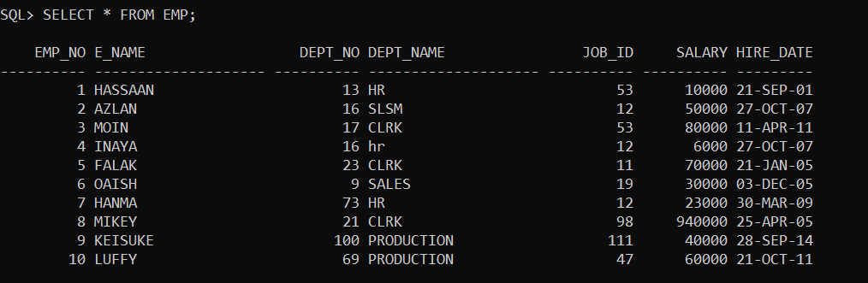Output: -

F. DISPLAY THE COMPLETE RECORD OF EMPLOYEES WORKING IN SALES DEPARTMENT:

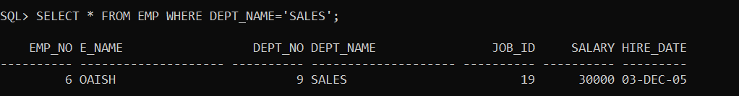Output: -

Q2) CREATE A TABLE EMPLOYEE AND DEPARTMENT WITH FOLOOWING SCHEMA BY APPLYING PRIMARY KEY AND FOREIGN KEY:

EMP(EMPNO,EMPNAME,SALARY,PHNNO)

DEPT(DEPTNO,DEPTNAME,LOCATION,JB_ID)

A.B.INSERT 5 ROWS IN BOTH THE TABLES AND DISPLAY INFORMATION OF BOTH TABLES:

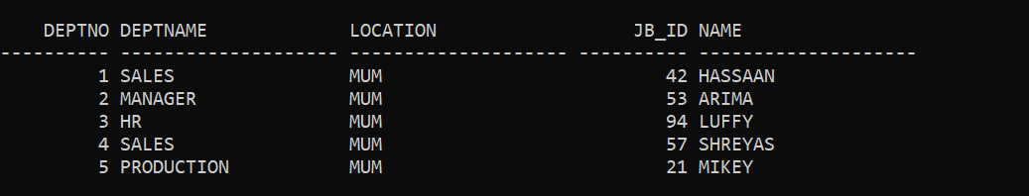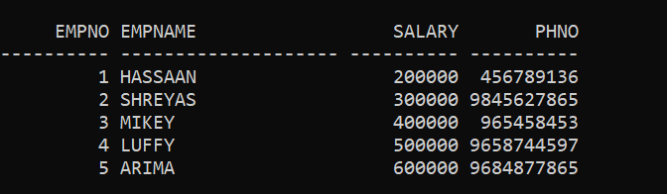

C.UPDATE DEPTNO OF EMPLOYEE SHREYAS TO 201:

Output: -

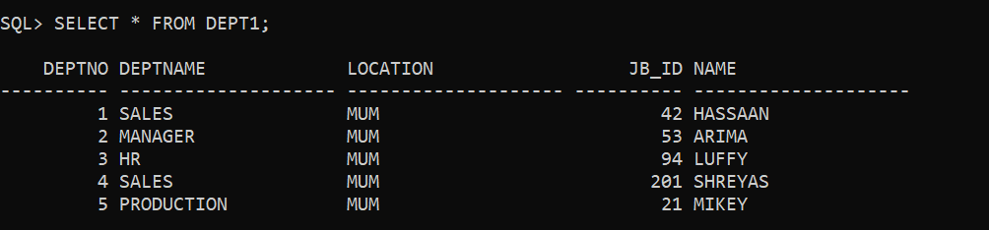

D.DELETE THE INFORMATION OF EMPLOYESS BELONGING TO DEPARTMENT SALES:

Output: -

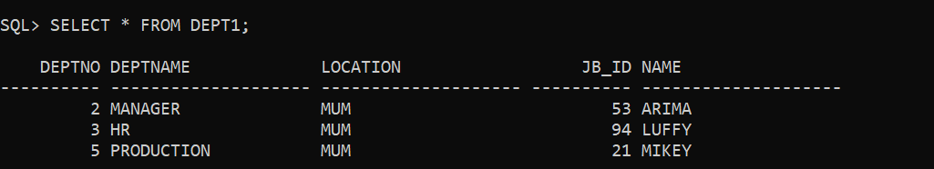

E.DISPLAY THE INFORMATION OF EMPLOYEE AND DEPARTMENT AND ANALYZE THE DIFFERENCE:

ORIGNAL TABLE: -



VS

TABLE AFTER UPDATING AND DELETING INFORMATION: -



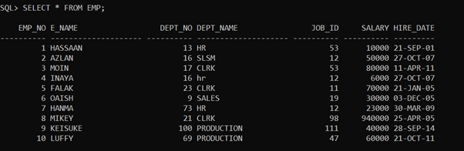ORIGINAL EMPLOYEE TABLE BEFORE MANIPULATION: VS

AFTER DELETING COLUMNS: -

